Making Meaning from Text
Quick Write:
1) How do authors use writing to express ideas?

2) Why can two people read the same text and understand it differently?

3) Who has more influence in making meaning from a text, the author or the reader? Explain.

Literary hermeneutics is…
Two Parts
The __________  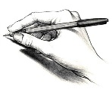 | The __________
Compare and Contrast
 | Clip 1 | Clip 2 | Clip 3
Format
Story
Style
Creator
Unique
What is “spin”? | How is “making meaning” important in our daily lives?

